FindYourPet

NESCOL |30082939

Graded unit 2 project

Radosław Rezler

2023

Table of content:

Introduction 3

Project goals 3

Key Dates 3

Background research 4

Observations/Interviews 4

Internet 4

Apps 5

Target audience 6

Waterfall methodology 6

MoSCoW 7

Must 7

Should 7

Could 7

Would 7

Functional requirements 7

General 7

Database 8

Non-functional requirements 8

Data binding design 8

Description 8

Design 9

Use Case model 9

Resources and materials 9

Hardware 9

Software 9

Websites 10

Materials 10

Programming language 10

Project plan 10

Analysis 10

Project plan 10

Solution Plan 11

Documentation 11

Developing 11

Testing 11

Video 12

Evaluating 12

Resources 12

TomsPlanner 13

Activity Diagram 13

Sequence Diagrams 14

Find a pet 14

Find a breed 14

Encyclopedia 15

Our mission 15

Class diagram 15

Textual analysis 16

Design 16

Interface usability and ergonomics 16

Interaction style 17

Logo and name 17

Sample graphics 17

Pseudocode 19

Sources 21

# Introduction

In today's world, every second household has an animal. Unfortunately, this phenomenon is burdened with many problems resulting from the wrong choice of animal and not knowing how to deal with it. The goal of my project is to create a program that will advise the user in choosing the right pet for him and providing information about pet, including those in the field of breeding. In addition, the application will have an animal encyclopedia and a section on conscious buying of animals. Based on deep background research (hereafter), I think that the initiative and the program itself will find many users.

The two main tasks of the application are: finding the right species of animal and searching for a specific breed of dog or cat. Both options will require the user to answer a set of questions about his habits, funds and preferences. The program will analyse the answers and in the feedback the user will get personalized information about the pets that match him and information why is that.

Additional application options are access to the database of cat and dog breeds, along with a photo and description, and the 'our mission' option, in which general information about the role of the animal's conscious choice along with tips will be available.

The project is created for the purposes of the Graded Unit 2 Exam, in accordance with strict recommendations, legal and ethical principles.

# Project goals

The main goal is to create an efficient application that provides the user with a number of predefined functions. The next stages of the project must meet all the requirements of the Graded Unit 2 exam, i.e. finishing in accordance with the deadline received and in compliance with legal and ethical principles, professional documentation, sticking to strictly defined tasks, taking into account the selection of appropriate tactics, strategies and tools. All of the requirements listed above have been strictly defined by my client - my school, and their exact assessment, broken down into individual sections, has been included in the marking guidelines template provided to me.

The client's requirements concern the creation of an application, website or other project that will show my skills and knowledge in areas closely related to this course. As the choice is mine, and part of the project is to find my niche - to create something unique, and due to the fact that I own many pets, I chose to create an application, the outline of which I will present in this document.

# Key Dates

* Planning - midnight on Monday 6th March 2023 (Week 5)
* Developing - midnight on Monday 8th May 2023 (Week 12)
* Video - midnight on Monday 15th May 2023 (Week 13)
* Evaluating - midnight on Monday 29th May 2023 (Week 15)

# Background research

## Observations/Interviews

For the purpose of research, I used a lot of materials that I found on the Internet. I believe that the knowledge found there, if supported by the name of the creator or a well-known certified organization - is more up-to-date than book studies. Even in the last few years, many rules regarding the behavioural upbringing of animals have changed, so I believe that it is necessary to focus on current studies in this field. However, I chose this project primarily based on my own observations. I know many people who have wonderful animals and take great care of them, but I also know people who had to give them away or even put them to sleep due to previous neglect or maintenance costs they were unable to bear. In addition, as the owner of 2 cats, and previously also 2 dogs and about 10 rats, I learned a lot from them based on all interactions and observations. I already know that it is not always easy to raise an animal correctly, and it is even more difficult to provide it with optimal conditions if you do not know enough about it, or if you do not have the appropriate funds and time. These are important things that need to be planned and organized before we get an animal, because a possible problem that may occur later will concern not only us but also other living beings that will depend on us.

I confronted my thoughts with people close to me to find a solution to the problem together and share our observations on this topic.

## Internet

For the purpose of online background research, I looked at the forums and facebook groups regarding animals. In addition, I found materials written by journalists that talked about people's problems with the wrong choice of pets (bought on impulse - like a movie, or occasions like birthdays, Christmas time) and the future consequences of this choice.

The problem of mistreatment of animals - including domestic ones is wide. Often, the first factor that prevents from properly dealing with animal is the wrong selection. There is no specific tool on the market that will find the right pet as well as provide specific information on animal care. Therefore, the future owner, discouraged by the enormity of choice, and then the work in finding the perfect pet often is guiding first by the appearance or own preferences. This program will show the user a list of animals and breeds that he can consider based on his preferences, but also only those that are within his range (amount of free time, funds, etc.). In this way, this problem will be deleted and the user will be further educated and happy with his choice.

The websites I have found either provide extensive knowledge that user need to analyse himself, or are in the form of a quiz, which is mostly entertainment and does not focus on all the important elements of the choice. In addition, none of the quizzes provide as specific data based on answers as my application will.

## Apps

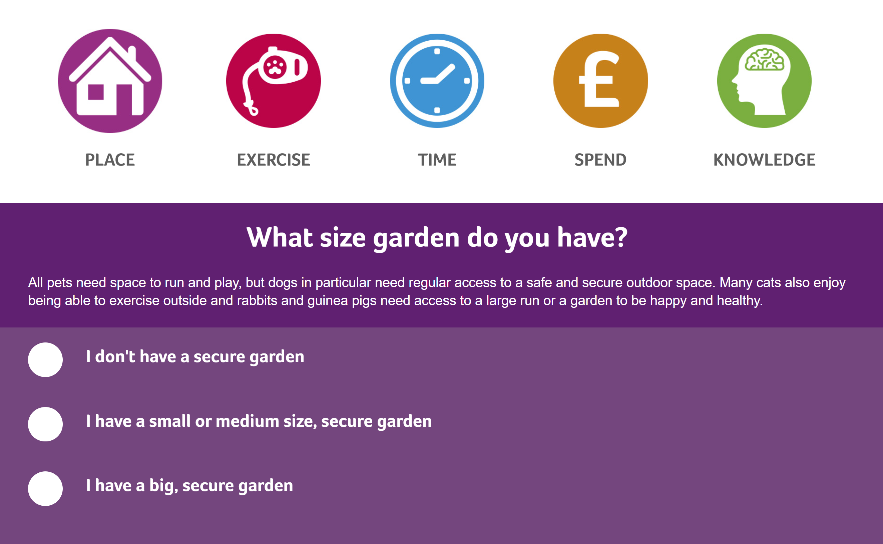

*https://www.pdsa.org.uk/taking-care-of-your-pet/choosing-a-pet*

Pros: the application contains a lot of information about animals, is colorful, well-built and clear.

Cons: the information is not exactly precise and accurate, the questions are not specified, no breed selection.

Summary: Questions in my application will be more specific. Although there was a lot of information, it was not entirely accurate, sometimes not even very true.

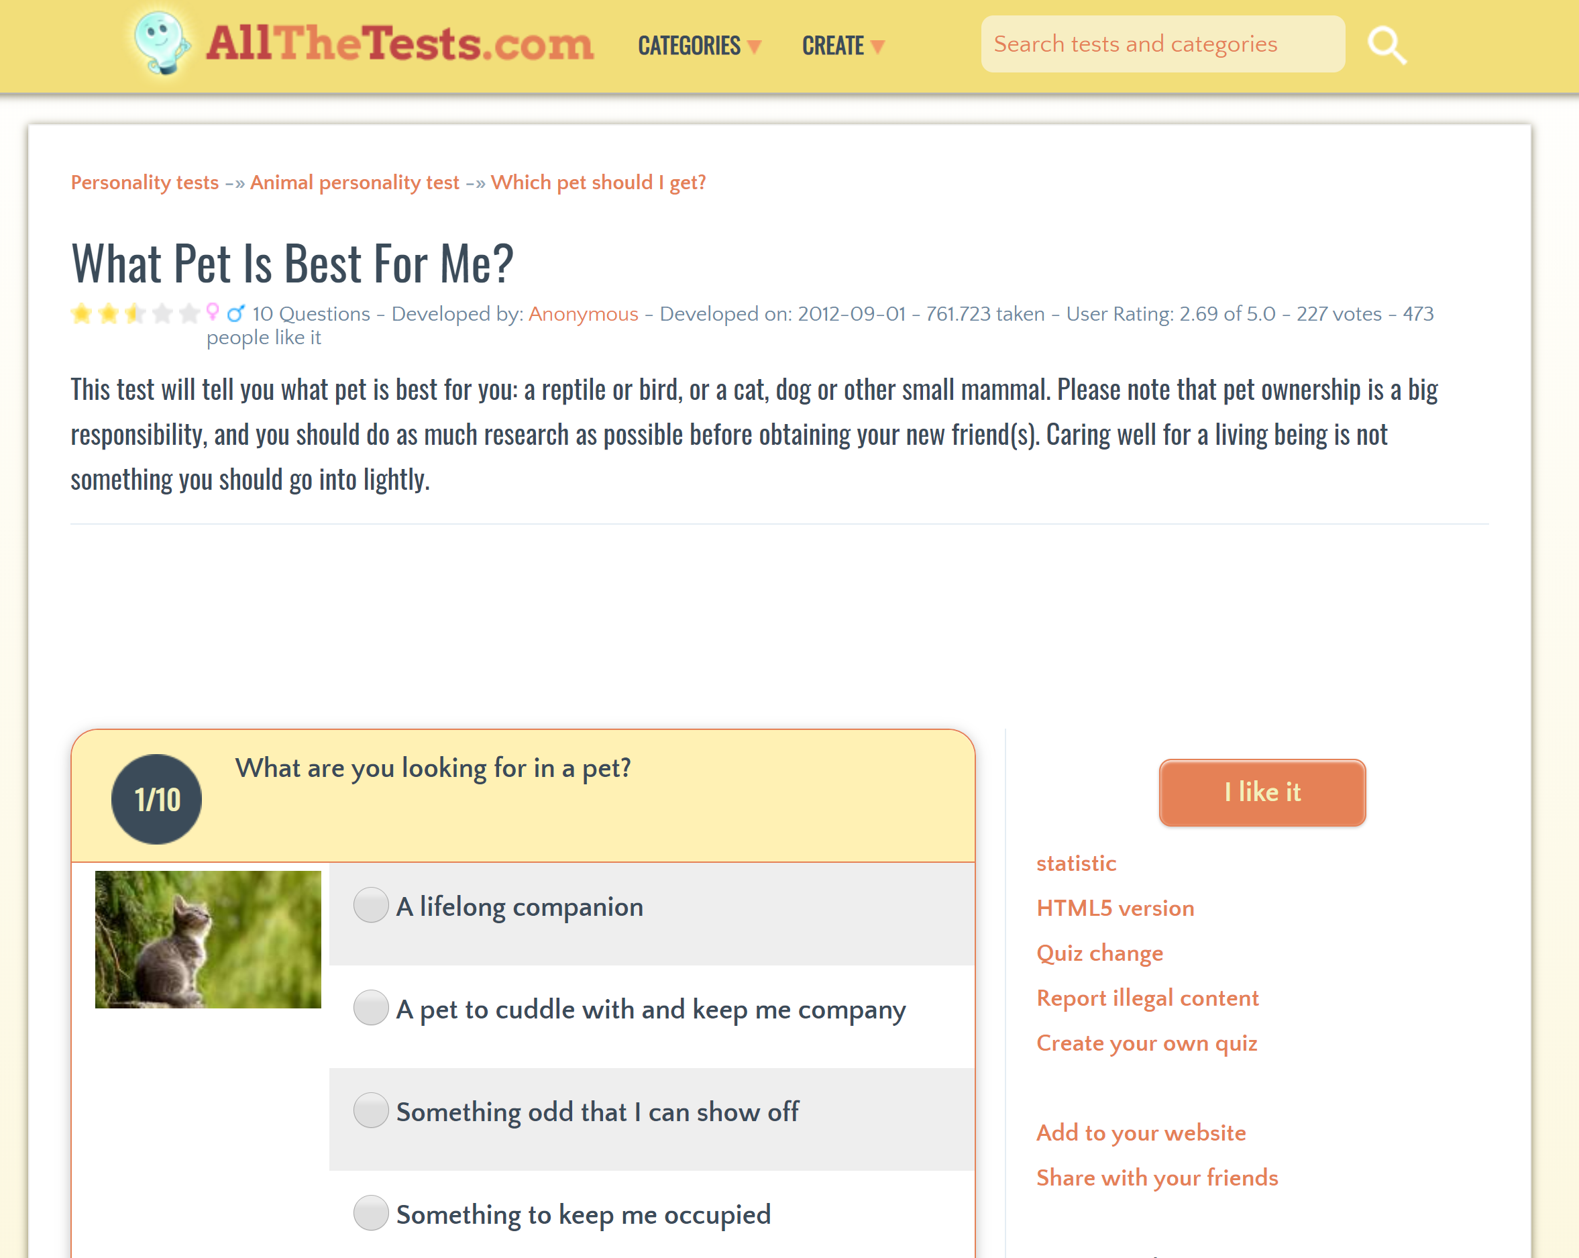

*https://www.allthetests.com/quiz30/quiz/1346285407/What-Pet-is-Best-For-You*

Pros: specific and precise questions, the page is clear and pretty.

Cons: not enough information about animals, no information about caring for them, no choice of breed.

Summary: My application will not only focus on the entertainment quiz, but will also address important issues, such as proper care of a particular animal. There will be more information on how to look after your pet well.

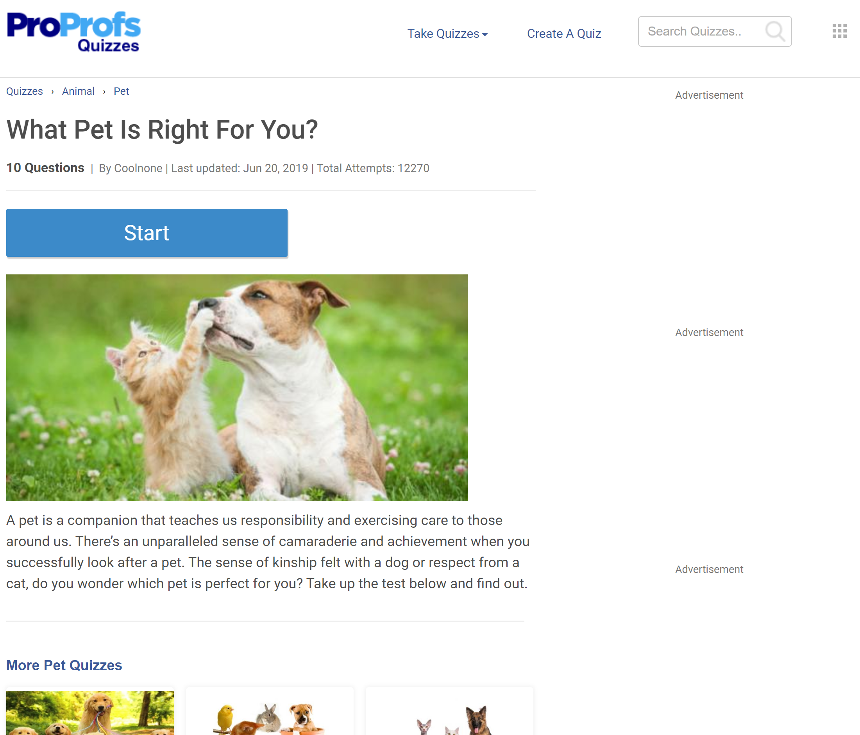

*https://www.proprofs.com/quiz-school/story.php?title=what-pet-is-right-you_1*

Pros: the page is clear, easy to use, simple questions.

Cons: little information about animals, information is not specific, questions are easy to predict.

Summary: The questions in my application will not be so obvious, it will not be easy to predict the answer to manipulate the result. The result is to be as compatible as possible with the actual possibilities of caring for the animal.

# Target audience

Statistical data show that on average every second household in the UK has a pet. This number is even higher in the US. Unfortunately, there are problems with such a large number of animals, resulting from the wrong selection of the seller and the animal, and general misinformation regarding care and obligations. The main target of the program are therefore both people planning to buy a pet and those who already have one. The program will be clear and easy to use so that it can be used by people of all ages and people with disabilities.

# Waterfall methodology

Due to the time frame imposed in advance, and the stages that I need to document, I decided to use waterfall methodology. I will gradually go through the stages of analyzing, creating, testing and documenting the project. This way I will be able to meet all the required criteria and efficiently manage time.

# MoSCoW

In order to ensure the right priority and transparency, I used the MoSCoW method, presented below, when planning the project. It refers to a program that is being created.

## Must

* Created according with ethic standards and all software licensing acts
* Display the interactive main menu with 4 options
* Separate sets of questions, depending on whether we are looking for a species or breed
* A personalized set of tips and information based on user responses
* Description of at least 6 different species of animals
* Description of at least 10 species of cats
* Description of at least 10 species of dogs
* Advice and information regarding the deliberate selection and purchase of pets
* Windows as a platform

## Should

* More dog and cat breeds
* The program name and logo are well-designed
* Clear interface
* Stable and fast program
* Properly selected graphics showing all species and breeds used in the application

## Could

* Mode for people with visual / hearing impairments
* More animal species
* Background music
* Other types of sound
* Mobile version

## Would

* Third-party certification
* Cooperation with shelters, breeders and shops (advertising, additional advice, on-line consultations)
* Additional options on the menu

# Functional requirements

## General

* Interactive menu with 4 options
* The option of returning to the menu after selecting each option
* Two of the options lead to a set of interactive questions
* Answering the questions generates the choice of species / breed
* The program displays information about the species / breed selected for the user
* The third option displays an interactive database of dogs and cats
* The fourth option displays additional information and tips

## Database

* Two dedicated question sets
* The algorithm responsible for the selection of species / breed
* Database of information on animal species
* Database of information about dog and cat breeds
* Information on the purchase and breeding of animals

# Non-functional requirements

* Professional - a program created according with ethic standards and all software licensing acts
* Usability - the program will be useful to people interested in buying a new pet and will broaden knowledge and good practices in animal care
* Time management - completion of the project in the required time
* Stability - maintaining code transparency, selection of appropriate functions and tools
* Performance – it is a small program that runs well even on old devices
* Security - the program does not store sensitive user data and does not cause any errors, does not interfere with computer components in an undesirable way
* User friendly - maintaining transparent colors and consistency
* Cost – program is not expensive to make
* Target - achieving all goals stated in the documentation for Graded Unit 2
* Free - creating a program available to everyone for free

# Data binding design

## Description

The entire database will be stored inside the program, not editable by the user (to ensure that the data is always correct). Specific pieces of information will be provided to the user when selecting various options from the menu, such as answering questions or displaying a list of all animals. The program will have an extension in the .exe format, however, the administrator, i.e. the creator/client, will also have a .py version of the application, which will allow editing and creating future versions of the program.

The database is divided into two categories - public and private. Most animals have public data, such as their description, but also private data, such as their size, cost of maintenance, activity, etc. defined in numbers 1-3 (this data will allow to find the best fit, based on the user's answers and assigning them score). Public data is made available to the user through the UI in read-only form and based on his choices in the menu. Private data can only be seen by the application administrator who has the development version of the application in the form of a project folder with files, including photos and .py code.

All data, both public and private, is stored in an in-memory data structure of the application.

## Design

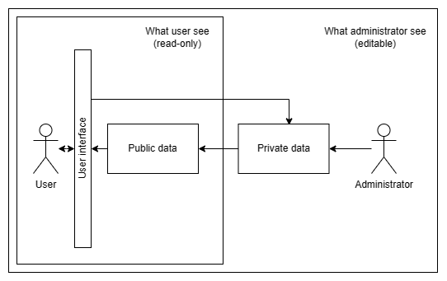

# Use Case model

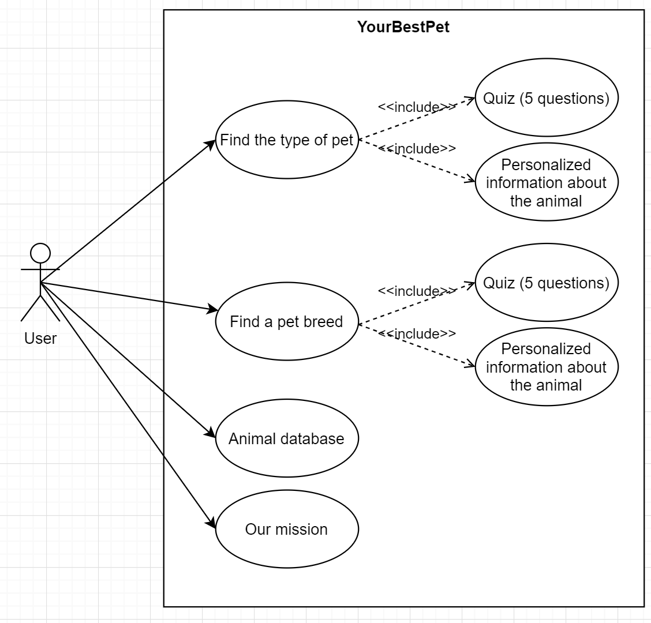

# Resources and materials

## Hardware

* Laptop Lenovo Y50-70 – second laptop used as a backup
* Laptop Asus ZenBook – main laptop with all programs ready to use
* Router TP-Link – provides very fast and stable broadband on every of my devices
* Additional peripherals – mouse, tablet – to speedup the process, tablet as a second monitor

## Software

* Microsoft Edge - the main Internet browser, well known, easy to use
* Google Chrome - additional browser, in case if something wouldn’t display properly
* PyCharm Community – program to write and run a python code, well known by me, with very useful options like error checks, creating project folders, auto-downloaded extensions
* Microsoft 365 – text editor to create professional documentation, provided by NESCOL free of charge with all file extensions supported by the school
* TomsPlanner - creating task schedules and efficient time management
* Draw.io - Use Case and Activity Diagram creator, that allows to work through website
* JustInMind – prototype design, easy to use

## Websites

All websites accessed till now are listed under Sources page. Other internet sources may be used in the future to find the best information about the topic.

## Materials

In addition to the above, my workplace is a private home with permanent access to the Internet. I also have the opportunity to learn from my teachers. At the school I attend, I also have access to a library containing books and technical magazines. There is also permanent internet access. The websites I used until this document was prepared are listed at the end of the document in the Sources section.

## Programming language

Python - the latest version of Python will allow me to create code efficiently. I learn this language at my university, I know its possibilities and I am able to get any help about it. Thanks to this choice I will save time and in case of problems I will know where to look for help. It is a popular language, widely used and with many active developers.

The abovementioned resources and materials should be enough for me to complete the task. However, because of the early phase of the project, I must point out that a few additional items may appear in the list given over time. In addition, all the websites and other sources that I used will be included in the summary documentation (final stage).

# Project plan

Analysis - this part is intended for choosing a project based on bakground analysis, gathering all necessary materials and choosing the right techniques.

* Find an idea confirmed by a background
* Write a brief
* Write project goals and target audience
* Find functional and non-functional reqirements
* Use Case model
* Full background with description
* Find the right tools and materials
* Record all resources

Project plan - the part responsible for dividing the project into smaller stages and setting the corresponding implementation dates.

* Extract milestones and smaller tasks
* Give tasks a specific time frame
* Create a graph of your work time
* Record all resources

Solution Plan – the part responsible for creating a specific implementation plan from the technical and visual side

* Finding the right techniques
* Creating an activity diagram
* Creating a logo
* Creating of design
* Creating of Pseudocode
* Record all resources

Documentation – last milestone from the planning category, responsible for checking if the documentation is full and looks good.

* Check all points
* Checking resources
* Formatting text

Developing – time responsible for creating a working prototype with technical documentation.

* Creating a technical prototype code
* Conversation with the client
* Creating a prototype of the visual part
* Conversation with the client
* Work on completing the entire program
* Creating technical documentation

Testing – milestone is responsible for testing the product and completing the entire project by applying patches. The whole process will be confirmed by technical documentation.

* Testing the product
* Create test plan and test log
* Making corrections
* Create test plan and test log
* Creation of full technical documentation

Video – Creating a 10 -minute video describing my project.

* Write a scenario
* First version
* Final version

Evaluating – creating a document confirming my experience and all other information related to the completion of the project.

* Introduction
* Overall project evaluation
* Assessment of assumptions and their fulfillment
* Strengths and weaknesses assessment
* Description of modifications made during creation
* Analysis of solutions to existing problems
* Analysis of acquired knowledge
* Ideas for improving performance on future projects
* Summary and formatting of the document
* Preparation for presentation and meeting with the client

Resources – resources that are needed to finish the project (besides software/hardware resources which are listed in another section of the document

* Myself as a worker
* Time
* Knowledge
* Hardware/Software (listed in another place of the document)

# TomsPlanner

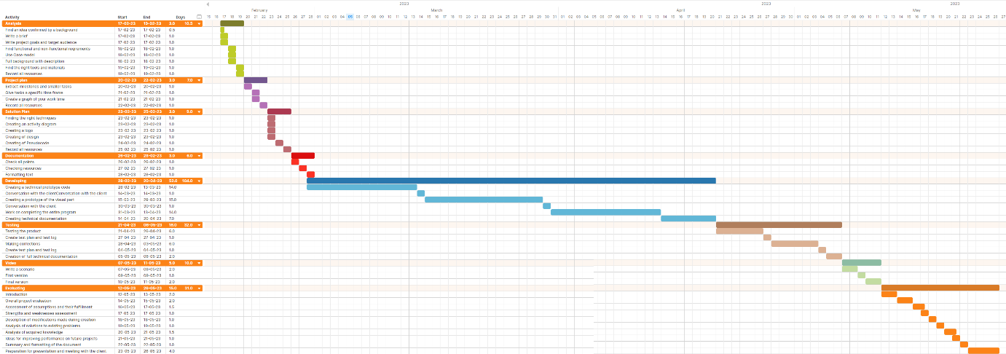

# Activity Diagram

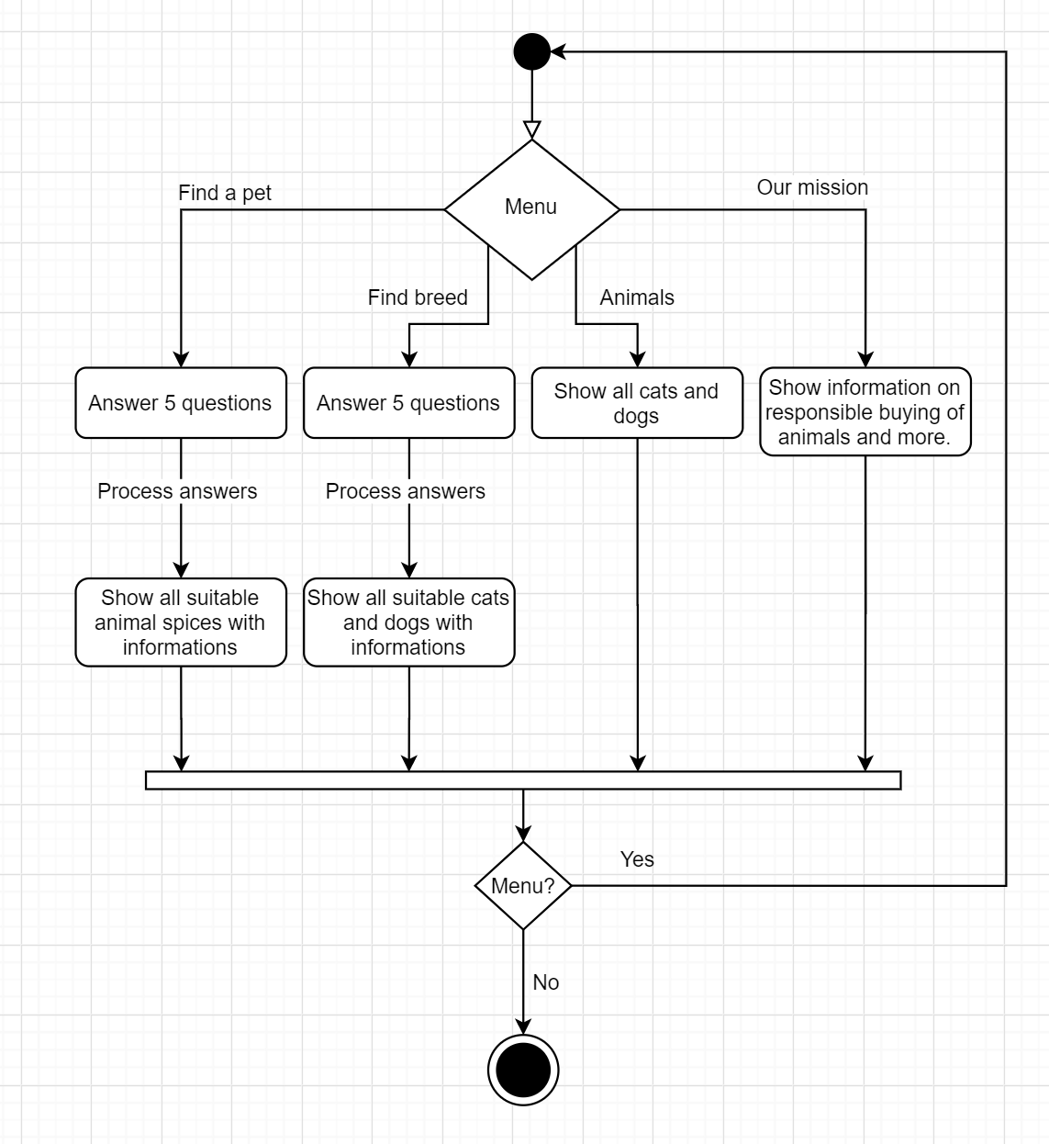

# Sequence Diagrams

## Find a pet

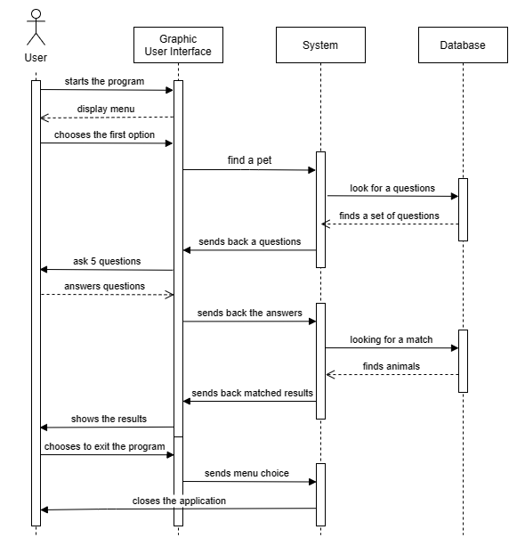

## Find a breed

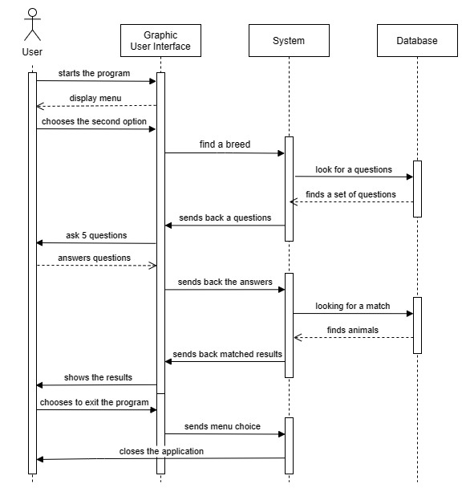

## Encyclopedia

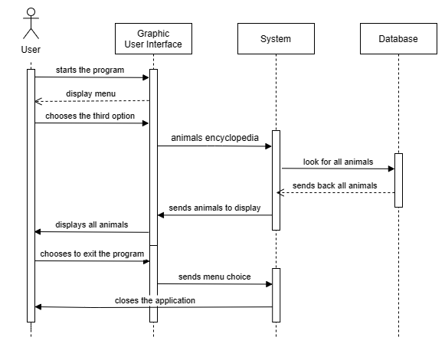

## Our mission

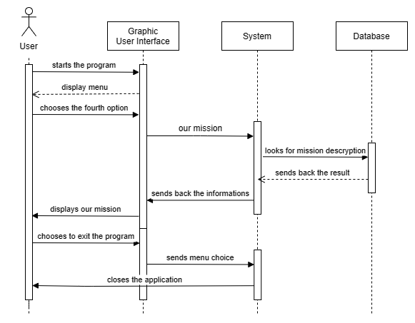

# Class diagram

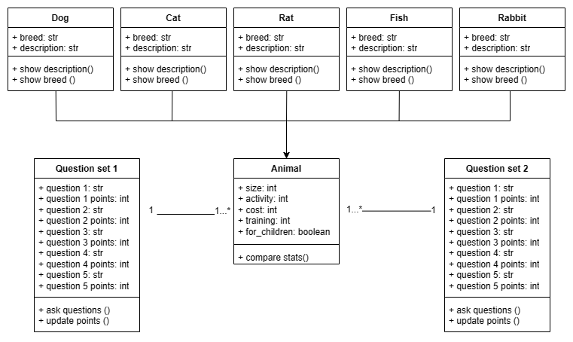

It is important to note that my project is based mainly on an advanced question and answer algorithm, including their analysis and detailed commentary. Therefore, the other types of static UML diagrams in this documentation are more useful for showing how an application works.

# Textual analysis

Various forms of technical analysis were undertaken to create the application project.

These include:

* different types of UML charts
* analysis of customer needs and potential requirements of future users
* designing the initial application interface
* how application will interacts with the user and internal data
* assigning the project time frame
* assigning appropriate methods of its implementation, including the necessary resources
* using models like MoSCoW and Waterfall
* background research and more…

Using so many analysis techniques, I was able to check whether my business model and view model would meet the needs of the client, future users and whether all systems would be compatible with each other.

In addition, I made sure that I had all the resources - both time and equipment, as well as a set of necessary information and knowledge to complete the project meeting all assumptions and time frames.

After a thorough analysis, I am able to guarantee that the project I am working on will be carried out in accordance with all the above assumptions.

As this documentation was created as a first stage of work, some parts of the project - in particular some parts of the design and the final appearance of the code may change.

However, none of the changes will affect the application's fulfillment of all the goals described in this documentation. The changes will mainly consist of adding additional elements to expand various elements of the application so that the final design exceeds its initial assumptions.

# Design

## Interface usability and ergonomics

First of all, the program was created in a minimalistic way. There are three assumptions behind this decision. Aesthetic - the program is pleasing to the eye, accessibility - the number of elements reduced to a minimum allows inexperienced people to familiarize themselves with all the functions offered by the application, ergonomics - the lack of distracting elements allows the user to efficiently focus on the task that he has decided to perform. As we can see, this assumption made it possible to implement many key principles from the very beginning, which should always be taken into account when designing the program we create.

Of course, it should also be assumed that the target group may include people with health and psychological problems, people of different faiths, cultures and beliefs. All this information is crucial, because it allowed not only to take into account the problems that the user may encounter and implement appropriate solutions to facilitate fluent work, but also to eliminate elements that could be offensive to some people or expose them to other ailments (such as flashing interface elements that may cause epilepsy in borderline situations). Bearing in mind all the above assumptions, below will be listed solutions that facilitate work with the program, making it effective and pleasant.

Other elements that facilitate work with the program, both for people with poor eyesight and those using the application on a mobile device, are the use of large buttons and large letters. As the application is not overcrowded with unnecessary elements that would take up space on the screen, enlarging all elements looks natural and there is no need to add an extra button to change the font size. This saves further troubles that could be encountered by inexperienced users due to unnecessary complications of the interface. On the other hand, this style continues to naturally match the look of the app, even though each element fills practically every possible space and is enlarged to the maximum by default.

## Interaction style

The system is based on a Graphic User Interface. Its advantage over the Command Line Interface is transparency, ergonomics and accessibility to a wide range of customers. It is the most intuitive system for inexperienced users. It allows for extensive personalization of individual elements, which will even better adapt the program to the set goals. The size of the application is so small and the style is minimalistic that the GUI will not adversely affect the speed of its operation. In the case of the created application, the user will select an option by using the mouse.

## Logo and name

The logo was designed using the correct techniques. It has only two colors, a simple style, a clear name and a creative message.

All the above-mentioned features are also components of good branding, which in the later stages of the development may contribute to the ease of remembering the brand and connecting its logo with the features and values that the product brings.

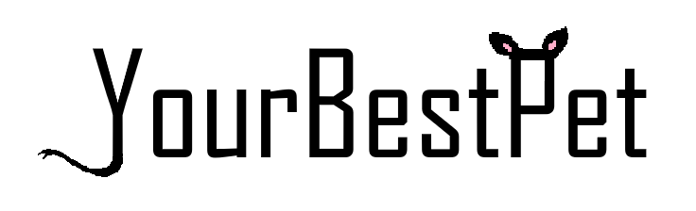

## Sample graphics

Below is an example of appearance along with the arrangement of elements and explanation of functionality.

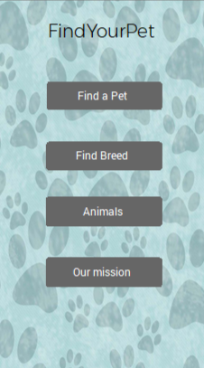

Sample main menu. The entire application is maintained in a subdued style. From this level, we can choose one of four options.

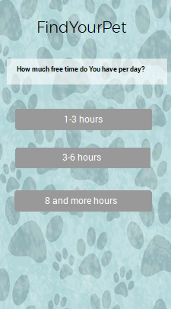

One of the sample questions. After answering five, we will continue to the next step.

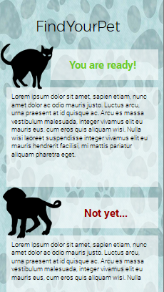

Screen displayed after answering five questions in the pet type search option. As we can see, the program concluded that the dogs did not match the user and gave a specific reason in relation to the answers. From this place we can go back to the menu or turn off the application. The buttons will be at the bottom.

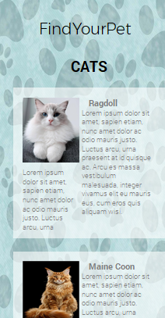

Album with all animals. We can read about each cat and dog, and return to the menu or close application using the buttons.

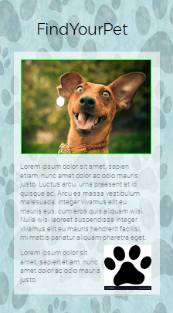

Part of the application that helps in choosing the best pets, by showing only the matched ones and gives many accurate tips with explanation, why this pets fits to the user based on his answers.

# Pseudocode

Create animal species library

Create animal breeds library

Create all questions for species

Create all questions for breeds

Set properties to all animal species (every animal, like ‘cat’,’dog’ has 5 properties, matching 5 different questions)

Set properties to all animal breeds (every breed, like ‘pitbull’,’ragdoll’ has 5 properties, matching 5 different questions)

Create all functions needed to find best results in internal database

Create graphic user interface

Assign functions to the buttons

Show menu

Ask for choice

If Find a pet

Get all answers

Show all answers results (by compraring the points gainded by answers with animal properties)

Show best pets, with description and explanation of the result

Ask for Exit or Menu

If Find breed

Get all answers

Show all answers results (by compraring the points gainded by answers with animal properties)

Show all breeds meeting all requirements

Ask for Exit or Menu

If Encyclopedia

Show all animals witch description

Ask for Exit or Menu

If Our Mission

Show our mission content

Ask for Exit or Menu

*This pseudocode is a very base model, only to show the general concept. Any of the elements may be changed through the developing stage.*

# Sources

* freeCodeCamp. (n.d.). Learn to code for free. freeCodeCamp. Retrieved December 2, 2023, from https://www.freecodecamp.org/
* YouTube. (n.d.). YouTube. YouTube. Retrieved March 5, 2023, from https://www.youtube.com/
* Codecademy. (n.d.). Learn to Code - for Free. Codecademy. Retrieved March 5, 2023, from https://www.codecademy.com/
* Stack Overflow. (n.d.). Stack Overflow - Where Developers Learn, Share, & Build Careers. Stack Overflow. Retrieved February 5, 2023, from https://www.stackoverflow.com/
* GitHub. (n.d.). GitHub: Where the world builds software. GitHub. Retrieved March 3, 2023, from https://www.github.com/
* OpenAI. (n.d.). OpenAI Chat. OpenAI. Retrieved March 5, 2023, from https://chat.openai.com/ProductPlan. (n.d.). Moscow Prioritization: A Product Management Framework. ProductPlan. Retrieved March 2, 2023, from https://www.productplan.com/glossary/moscow-prioritization/
* PDSA. (2021). UK Pet Populations of Dogs, Cats and Rabbits. PDSA. Retrieved January 5, 2023, from https://www.pdsa.org.uk/get-involved/our-campaigns/pdsa-animal-wellbeing-report/uk-pet-populations-of-dogs-cats-and-rabbits
* Found Animals Foundation. (n.d.). Why Do Animals End Up in Animal Shelters? Found Animals Foundation. Retrieved September 15, 2022, from https://www.foundanimals.org/why-do-animals-end-up-in-animal-shelters/
* ASPCA. (n.d.). Pet Statistics. ASPCA. Retrieved March 5, 2023, from https://www.aspca.org/animal-homelessness/shelter-intake-and-surrender/pet-statistics
* American Kennel Club. (n.d.). Breeds. American Kennel Club. Retrieved March 5, 2023, from https://www.akc.org/dog-breeds/
* The Cat Fanciers' Association, Inc. (n.d.). Breeds. The Cat Fanciers' Association, Inc. Retrieved March 5, 2023, from https://cfa.org/breeds/
* Purina. (n.d.). Cat Breeds. Purina. Retrieved March 5, 2023, from https://www.purina.com/cats/cat-breeds
* Dogtime. (n.d.). Dog Breeds. Dogtime. Retrieved March 5, 2023, from https://dogtime.com/dog-breeds
* Hill's Pet Nutrition, Inc. (n.d.). Cat Breeds. Hill's Pet Nutrition, Inc. Retrieved March 5, 2023, from https://www.hillspet.com/cat-care/cat-breeds
* PETA. (2018, September 26). Why Do People Abandon Animals? PETA. Retrieved March 1, 2023, from https://prime.peta.org/2018/09/why-people-abandon-animals/